ICT02 – LIBRARY MANAGEMENT
Description
Instruction:
1.if you are using TLAB**, Sample compile and run JCL is available in "TLABADM.LAB.SYS.COMPRUN". Please go in view mode and copy the members to your deliverable dataset.
2. if you are using TLAB**,the IP address is 10.142.149.210 and the Port is 623 to connect to Mainframe Terminal
Please do not EVALUATE and just SUBMIT the code for Evaluation - CC/MOCK/ICT assessments.

Objective:
Create a COBOL DB2 application for LIBRARY MANAGEMENT
Using ISPF
- Create a PDS with the following parameters given below.

NOTE: USERID must be your Mainframe ID.

For the MF ID provided for the Lab Assessment, use the below specified details

- DATABASE: DBLAB01
- TABLESPACE: Use the below details for Table space name based on the provided MF ID.
ID Range | Table space
TLAB001-TLAB030 | TSLAB1
TLAB031-TLAB060 | TSLAB2
TLAB061-TLAB090 | TSLAB3
TLAB091-TLAB120 | TSLAB4
TLAB120-TLAB140 | TSLAB5

Ø PLAN:LABPL<yyy>, PACKAGE: LABPK<yyy>.
<yyy> - Denotes last 3 digits of your Lab Assessment MF ID.

Using SPUFI
1. Create a member DBICT2SC inside USERID.MYLIB.DB2.ICT02 and write SQL to create the below tables using SPUFI
MEM_DET - To hold all details about the orders.
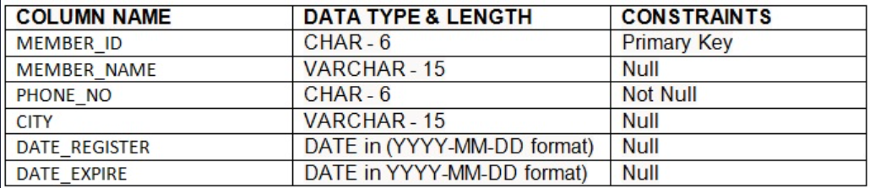
BOOK_DET TABLE - To hold book lending details
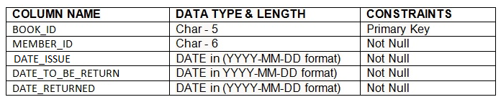
2. Create a member DBICT2SI inside USERID.MYLIB.DB2.ICT02 and write SQL to load the below tables using SPUFI
MEM_DET
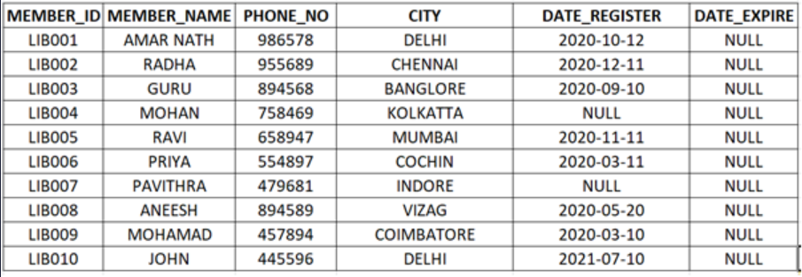
BOOK_DET
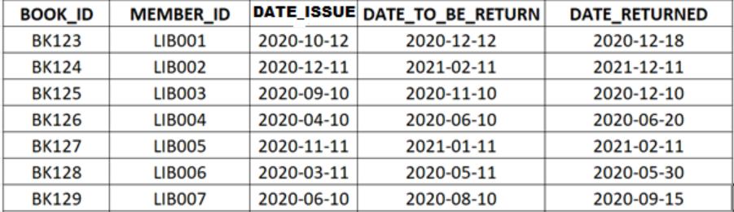
1. DCLGEN:
- Use DCLGEN option to generate host variable for the table MEM_DET, and BOOK_DET
- Store the host variable in the members MEMDCL and BOOKDCL in the PDS USERID.MYLIB.DB2.DCLGEN
2. COBOL Program
- Create a Member name DBICT2CB inside the PDS. (USERID.MYLIB.DB2.ICT02).
- Write a COBOL program to perform the following functions.
Input : Data fetched from table MEM_DET & BOOK_DET
Table to be updated : MEM_DET
Output file : USERID.DB2.ICT02.OUTPUT.PS1
DD name to be used for output file : OUTMEM
Note: Please use only the above mentioned DD names. Do not use COPYBOOKs for declaring input or output file layout in COBOL program.
- Using a cursor01.
- Select all order records from table MEM_DET table order by MEMBER_ID.
- Using null value handling technique, verify whether the field DATE_REGISTER holds any null value. If any null values present, Do not process that record and continue processing the next record. For records without null values in DATE_REGISTER field, continue processing the next step
- Calculate DATE_EXPIRE using following formula.
  - Add 2 years to the DATE_REGISTER
  - Ex: if DATE_REGISTER is 2020-01-01 then DATE_EXPIRE is 2022-01-01
5. Update DATE_EXPIRE for each records in the MEM_DET table
6. Using a cursor02 ,
7. Join the MEM_DET and BOOK_DET table to select BOOK_ID, MEMBER_ID, MEMBER_NAME, PHONE_NO, CITY, DATE_ISSUE, DATE_REGISTER, DATE_TO_BE_RETURN ,DATE_RETURNED and order the result by MEMBER_ID
- Using null value handling technique, verify whether the field DATE_REGISTER holds any null value. If any null values present, do not process that record and continue processing the next record. For records without null values in DATE_REGISTER field, continue processing the calculate FINE_AMT.
9. Use the below steps to calculate FINE_AMT for the members
- Calculate
LENDING_PERIOD = DATE_RETURNED - DATE_TO_BE_RETURN
§ Use below table to calculate FINE_AMT
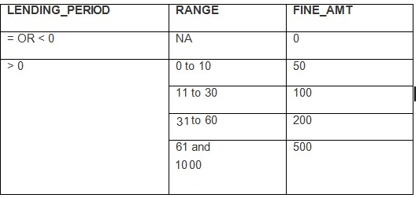
Ex: 1. If LENDING_PERIOD IS -34 then FINE_AMT is 0
2. If LENDING_PERIOD IS 25 then FINE_AMT is 100
10. Write the updated details into the PS1 file
- Allocate a PS1 dataset in the RUNJCL with record length 100 and with naming convention as below.
USERID.DB2.ICT02.OUTPUT.PS1
OUTPUT
11. LAYOUT :
NOTE: One space filler is to be inserted between each field.
12. Declare the necessary input and output variables as per the coding standards.
13. Please follow coding Standards and paragraph should be written in order.
14. Verify and confirm the output using SPUFI.
Note: Sample compile and run JCL is available in "TLABADM.LAB.SYS.COMPRUN". Open the PDS in view mode and copy the members to your deliverable dataset.

Evaluation Procedure:
1) Use your JCL to pre compile and run and test your program with the necessary inputs and make sure you get the return code MAXCC 00 before Submitting for the Evaluation.
2) Download your dataset (USERID.MYLIB.DB2.ICT02 (DBICT2SC), (DBICT2SI) and (DBICT2CB) to your system and name the file as DBICT2SC.txt, DBICT2SI.txt and DBICT2CB.txt.
3) Download your dataset (USERID.MYLIB.DCLGEN (MEMDCL) and (BOOKDCL) to your system and name the file as MEMDCL.txt and BOOKDCL.txt
4) Download your run JCL with the necessary inputs as per the QB Requirement and name it as RUNJCL.txt
5) Drag the file into the code Editor.
6) Then Press Evaluate button for Evaluation.

Kudos!You have earned some XP points.

